PROJECT 7 – SOUND-CONTROLLED DESK LAMP

DESCRIPTION
This project creates a desk lamp that can be controlled using claps or loud sounds. The sound sensor toggles the lamp modes, while a potentiometer adjusts the brightness and colour intensity of the RGB LED.

USE CASE
Hands-free lighting, smart desk lamps, bedroom lighting, interactive electronics.

COMPONENTS NEEDED
- Arduino Uno
- Arduino USB cable
- Breadboard
- Sound Sensor Module
- RGB LED
- Potentiometer
- Jumper wires

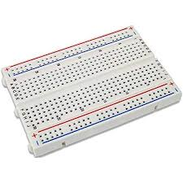

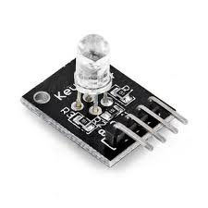
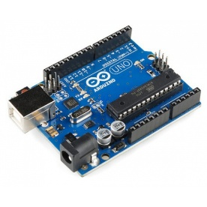
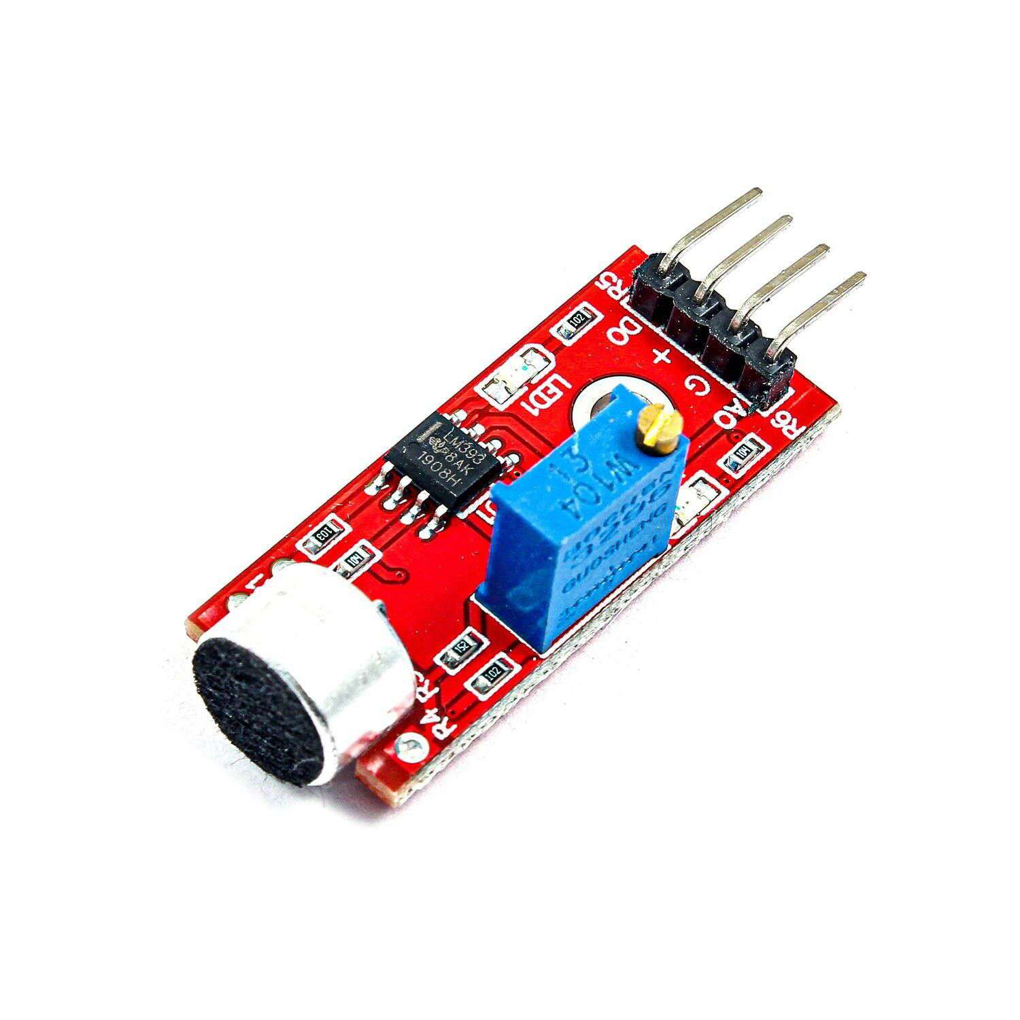
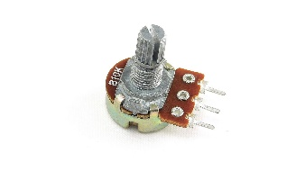
Breadboard
Arduino Uno

RGB Light

Jumper wires

Arduino USB cable

Sound sensor module

Potentiometer

CIRCUIT CONNECTION

Step 1:
Connect one jumper wire from the 5V pin on the Arduino Uno to the positive rail of the breadboard and connect another jumper wire from the GND pin on the Arduino Uno to the negative rail of the breadboard.
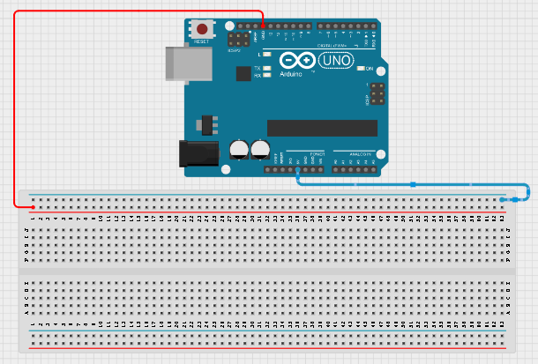

Step 2:
Place the SOUND SENSOR on the breadboard.
Connect the sound sensor:
- VCC → 5V
- GND → GND
- DO → Pin 7
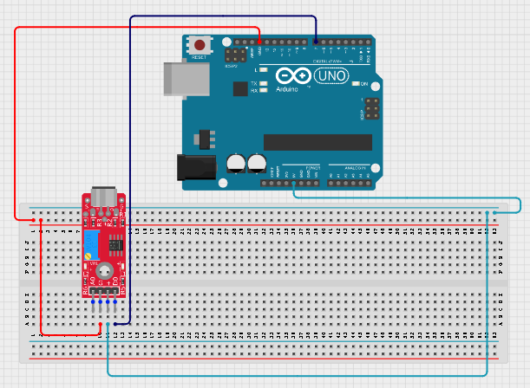

Step 3:
Place the RGB LED on the breadboard.
Connect the RGB LED:
- Red → Pin 3
- Green → Pin 5
- Blue → Pin 6
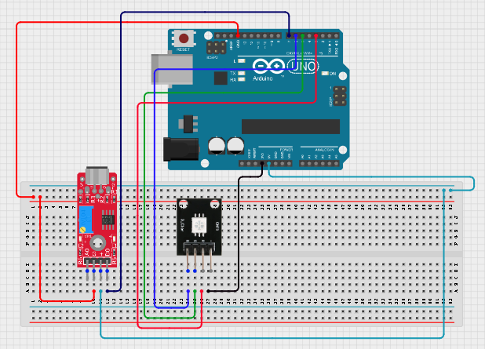

Step 4:
Place the POTENTIOMETER on the breadboard.
Connect the potentiometer:
- Left pin → 5V
- Right pin → GND
- Middle pin → A0
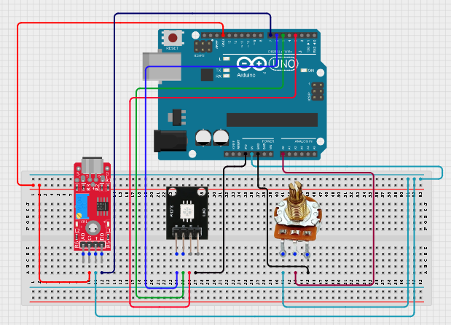

Step 5:
After completing the wiring, connect the Arduino Uno to the computer using the USB cable.

PROGRAM

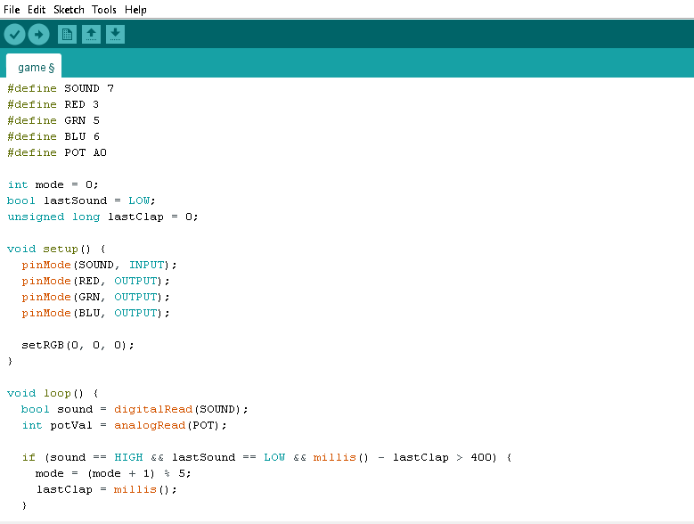

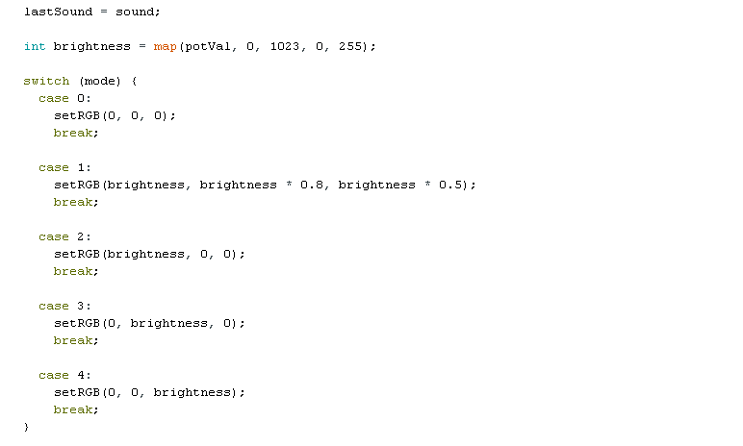



EXPLANATION
The sound sensor detects claps and cycles through different lamp modes. The potentiometer controls brightness, allowing the RGB LED to display different colours at adjustable intensity levels.

UPLOADING THE CODE

Step 1:
Open the Arduino IDE.

Step 2:
Copy and paste the code into a new sketch.

Step 3:
Select Arduino Uno from Tools → Board.

Step 4:
Select the correct COM port from Tools → Port.

Step 5:
Click Upload.

OBSERVATION
- Each clap changes the lamp mode.
- The potentiometer adjusts brightness.
- The RGB LED changes between multiple colour presets.

CONCLUSION
This project demonstrates sound sensing, PWM control, RGB colour mixing, and analog input processing.

